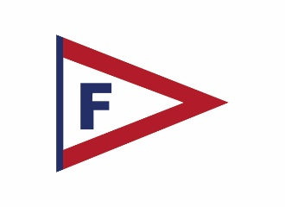
Florida Yacht Club would like to announce our Membership Recognition Program! This program provides a great opportunity to enhance the club experience and provide more personalized service among our membership.

We have partnered with EA Photography, a national portrait studio, to manage our Membership Recognition Program, and they will provide an on-site photographer at the club starting August 6th, 2025. They will be available by appointment only:
Wednesdays - Fridays from 11 am until 8 pm
& Saturdays - Sundays from 10 am until 7 pm.

For more information on their company and experience, please visit their website at www.eaclubs.com.

For a quick overview the program, you may watch this 2 Minute Video: Click Here for the Video

If you are not interested in participating, please email or call EA Photography and you will not be contacted for an appointment.

To make this project successful, we recommend the following:

- Each member and their families participate.
- All participants wear business or dressy attire, long sleeves and darker colors are suggested.
- Schedule enough time to be photographed and make your selection immediately following the sitting.
- Since prime appointment times fill up quickly, please reschedule your sitting in advance, if needed, as a courtesy to other members.

To receive priority appointments, you may schedule an appointment online by click the following link: Schedule Your Appointment. Otherwise, please contact EA Photography via email at MyClub@eaclubs.com or by phone at 800-653-5766.

This endeavor is part of the continuing efforts of Florida Yacht Club’s management to provide our membership with the best possible services. Thank you for your participation and continued support of your club.

If you wish to Fax, please use this convenient Form and Fax to 714-523-8801.

Member’s name: _____________________________________________

Spouse: _______________________________

Ages of children (if any) _______ _______ _______ _______

First Choice Date and Time: ________________Second Choice ________________

Please confirm to: __________________________ Phone: _____/_____-_________

